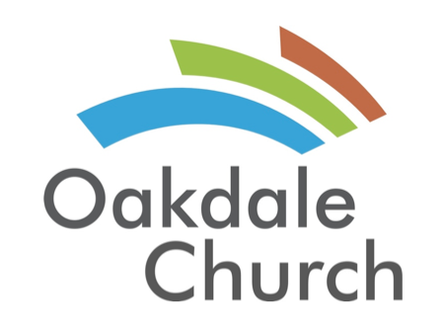

Week 1- Treble Clef, Notes on the Piano, Major Scales and Major C- Scale

Week 2- Review, Note Durations, Sharps, Flats, and C- Chord

Week 3- Review, G- Scale, F- Scale, G- Chord, F-Chord

Week 4- Review, Song introduction and practice

Week 5- Review, Song Review and practice

Week 6- Review, Song Evaluation

