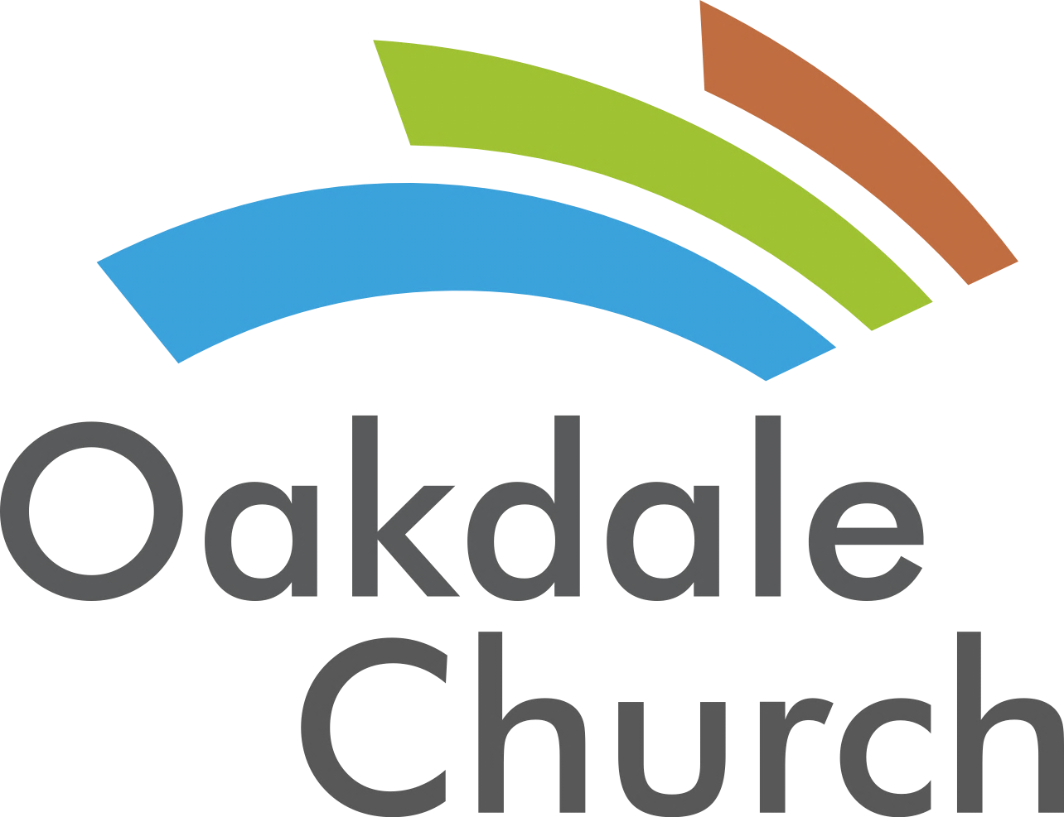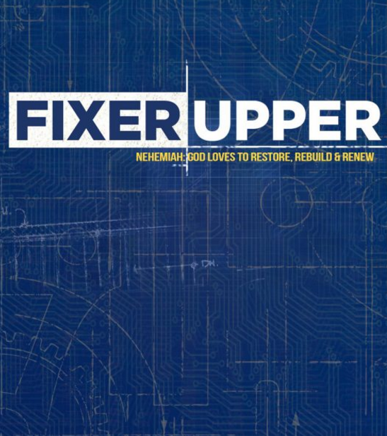­

#### Inside all of us are hidden struggles that can lead to bigger problems if we fail to address them. Join us as we learn how to fix them mess inside of us!

**Making the changes that matter most.**

**July Series:**

**Making the changes that matter most.**

**July Series:**

#### Inside all of us are hidden struggles that can lead to bigger problems if we fail to address them. Join us as we learn how to fix them mess inside of us!

Welcome to   
Oakdale Church

Follow us at:   
Twitter: @oakdalechurch  
Facebook: facebook.com/oakdalecog

Welcome to   
Oakdale Church

Follow us at:   
Twitter: @oakdalechurch  
Facebook: facebook.com/oakdalecog

**- June-July**: Summer Camps- Register online

**- August 11**: Heart screening. Info will be available online.

- **August 17-19**: Church of God Elevate Conference is a set of services for Pastors and their churches. Oakdale is going to be highlighted Friday night and you are welcome to join us. The conference is held at West Metro Church of God in Newnan, GA. Services begin at 7pm each night.

# Upcoming Events:

# Upcoming Events:

**- June-July**: Summer Camps- Register online

**- August 11**: Heart screening. Info will be available online.

- **August 17-19**: Church of God Elevate Conference is a set of services for Pastors and their churches. Oakdale is going to be highlighted Friday night and you are welcome to join us. The conference is held at West Metro Church of God in Newnan, GA. Services begin at 7pm each night.

-March 7th- April 18th we will launch free piano lessons for adults and students. The lessons are every Tuesday and last for 6 weeks with one off week. Students begin at 6pm and adults begin at 7pm. Visit our website to register.

-March 10th (Safe House) – Join us as we go to serve the homeless and low income families in Atlanta a meal Friday evening at 6pm.

-March 26th (Volunteer Meeting) – We will be hosting a volunteer and leadership meeting for those currently serving or those interested in serving at Oakdale.

Website: www.oakdalecog.com   
Twitter: www.twitter.com/oakdalechurch  
Facebook: www.facebook.com/oakdalecog  
Email: brian@oakdalecog.com

# Connect with us:

We understand you have doubts and questions. Next Steps is a class that offers a conversation about faith and religion. To join, simply call or email us at any time!

### Next Steps:

**While Oakdale Church has been around since the 1950’s, the congregation has recently gone through some dramatic changes. The church has decided to relaunch itself into the community. Our mission is simple: We exist to help people discover and follow Christ. We plan to fulfill our mission by demonstrating the love of God in practical ways to our community. If we can ever partner with your family, business or school then please contact us! We want to help serve you if we can. Thanks for being our guest!**

### About us:

### About us:

**While Oakdale Church has been around since the 1950’s, the congregation has recently gone through some dramatic changes. The church has decided to relaunch itself into the community. Our mission is simple: We exist to help people discover and follow Christ. We plan to fulfill our mission by demonstrating the love of God in practical ways to our community. If we can ever partner with your family, business or school then please contact us! We want to help serve you if we can. Thanks for being our guest!**

We understand you have doubts and questions. Next Steps is a class that offers a conversation about faith and religion. To join, simply call or email us at any time!

### Next Steps:

Website: www.oakdalecog.com   
Twitter: www.twitter.com/oakdalechurch  
Facebook: www.facebook.com/oakdalecog  
Email: brian@oakdalecog.com

# Connect with us:

Welcome to Oakdale Church

Welcome to Oakdale Church