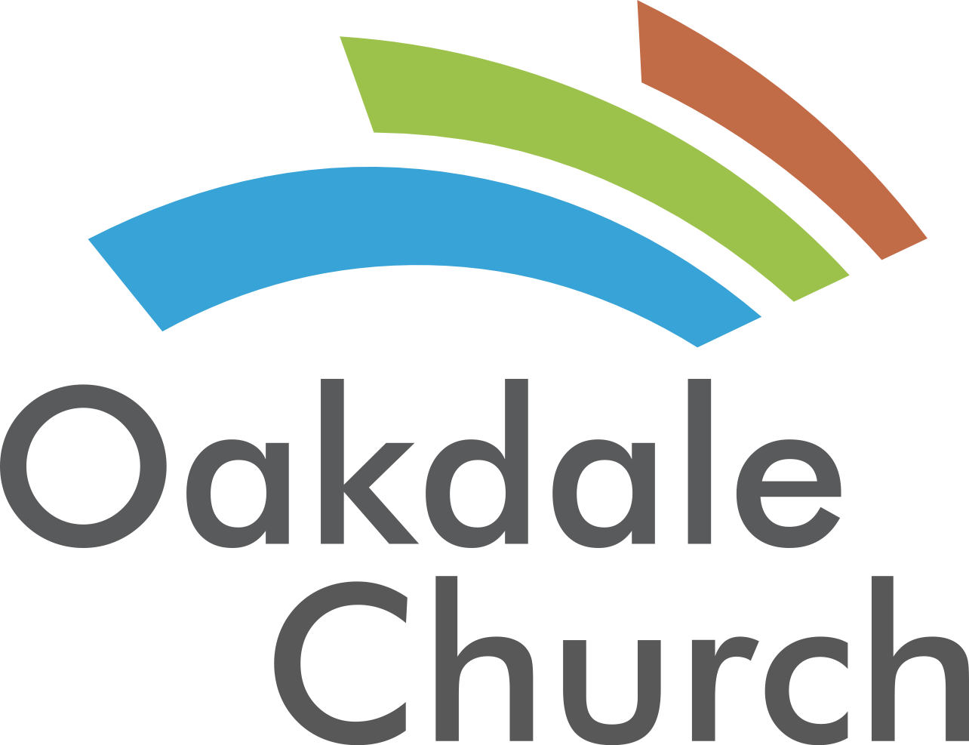

Seasonal Ministry- Brian Downing
Fall Ideas:

Serve Together-
-Volunteer Drive
-Come back to church day/Friends & Family Day
-Job Fair: Go to businesses who hire around holidays and offer to host them.
-Medical Clinic: (Life Line Screening)
-Host HOA Meetings
-Free Music Lessons – Piano, voice, guitar, drums, etc. (great for raising up a younger generation and introducing yourself to the community.)
-After school Programs: Imagine That Inc. comes into churches for after school programs for kids. Kids learn, are exposed to your church and you win in the sight of the community.
-6 Week Classes (Holiday baking classes, Holiday Craft classes, building classes, art classes, Holiday Music lessons, etc.) These 6 week classes are meant to give you influence leading to a holiday invite that an outside family may choose to join because of a positive friendship established in the classes.
-Homeless Shelter: Serving food or food/clothing drive.

Have Fun Together-
-Nights of worship
-Fall Festival
-Trunk or Treat
-Rec Leagues (Softball, bowling, etc.)
-Thanksgiving & Christmas Parties
-Christmas Photo Op: Create a photo op for families outside of your church.
-Workout

Relaunch Together-
-Evaluation of Church ministries for the upcoming year
-Vision Casting (Staff, Volunteers & Church)
-End of year financial teaching
-Launch new classes
-Leader development
-Small Groups
-Holiday Idea Meetings
-Retreats (Marriage, Staff, Student)

