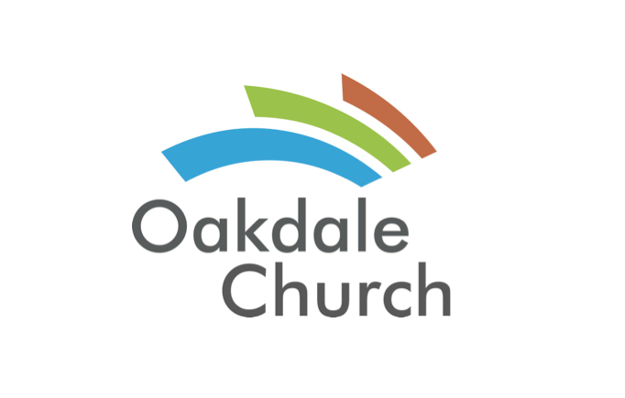
Week 3- Review, G- Scale, F- Scale, G- Chord, F-Chord
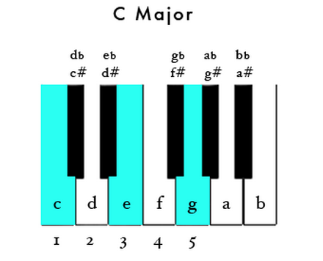
Major Scale = W, W, H, W, W, W, H
Whole, Whole, Half, Whole, Whole, Whole, Half

